A FRAMEWORK FOR DEVELOPING COLLABORATIVE CASE TOOLS

Kevin Soon Swee Sin and Sellapan Palaniappan
Department of Information Technology
Malaysia University of Science and Technology
email: sssoon@must.edu.my
sell@must.edu.my

ABSTRACT

This paper proposes a light-weight framework called LICOSE (LIghtweight COllaborative SErvices) that is suitable to execute Java programs on a client that has constraint-limited environment such as Java Runtime Environment (JRE) for applets and Personal Digital Assistants (PDAs). This framework also allows high-level calls to be made to leverage the underlying publish/subscribe mechanism provided by the Java Message Services (JMS). Although socket connections are created and managed behind-the-scenes, the distributed collaborative application developer need not worry about the internal plumbing involved. This framework thus acts as both a Façade (for simplifying the intricate JMS interfaces) and a Proxy (for providing a surrogate interfaces for developers to invoke upon). A prototype CASE tool with collaborative features is developed using this framework.

Keywords: Distributed System, Collaborative System, Distributed Collaborative System, Collaborative CASE Tool, JMS

1.0 INTRODUCTION

The advent of the Internet allows people in different locations to work in collaboration in an almost real-time manner. Among the most popular applications include instant messaging, online games, and the like. Their similarities lie where each remote client application can generate an event such as sending a text message or making a move in a chess game. The collaborative system will then allow such updates to be propagated to other remote clients. As such, each remote client will feel the illusion of sharing the same view of the workspace.

Although these systems are common for text-based applications, there is a need to incorporate similar features for graphical design tools such as CASE (computer-aided software engineering) or EDA (electronic design automation) tools which currently are stand-alone tools. Since collaboration can be achieved according to different levels of responsiveness and granularity of the propagated events [2], designers using these stand-alone systems are still able to collaborate using a CVS (Concurrent Versions System). But to achieve an almost real-time joint collaborative environment for these design tools requires a good asynchronous event notification mechanism such as what is provided by the JMS (Java Message Services).

- LITERATURE REVIEW

Socket programming is a suitable approach to develop a not-too-complex networked application. This technique involves creating a socket which is used as a communication channel to transmit and receive messages. We can use socket programming to develop applications that is based upon two typical architectures, namely the client-server and peer-to-peer.

For the client-server architecture, the server is host that will keep on waiting for incoming connections. When a client connects to the server, the server would instantiate a socket. This socket instance will be used to instantiate a handler object that runs on a separate thread. These handlers would be kept in a collection object (for example a Hashtable or Vector for Java).

The server will continue to wait for more incoming connections while the handler is running in a separate thread. The reason to have the handler in a separate thread is because the server will need one thread to wait for new incoming connections. Since this is a blocking process, the separate thread is needed to allow the handler object to wait for messages being sent by their corresponding clients. Thus, for every new client that is connected to the server, a new socket and a new handler will be created. Each handler then represents each connected client.

In a distributed environment, if a client broadcasts a message to all other connected clients, then the message will first arrive at the client’s handler at the server side. The handler will inform the server to broadcast this message to all other clients. This can be done by looping through all the other handlers that was kept by the collection object earlier. Each handler will then be invoked to transmit the message.

Complications arise when there are many clients connected and thus when the server wants to broadcast a message, it needs time to loop through the collection of handlers. It could be possible that during this time, a new incoming connection (recall that this runs on a separate thread) is created and the server needs access to the current collection object so that it can insert the newly created handler instance. At this point, since there are two threads having access to the collection, which is a shared resource, then we need to ensure that our loop lies in the critical region. The synchronized keyword can be used to ensure that the region is thread-safe and it would look something like the code in Fig. 1.

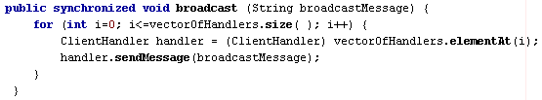

Fig. 1: Code snippet for broadcasting

If there are many messages to be broadcasted, then this synchronized method will keep locking the method that uses the collection object (i.e. vectorOfHandlers for the above snippet).

Furthermore, the programmer also needs to manage the collection object so that clients who are disconnected would have their corresponding handler instance in the collection object be removed gracefully. This again requires access to the collection object and requires further locking on that object. Fig. 2 depicts how the architecture will look like when using socket programming.

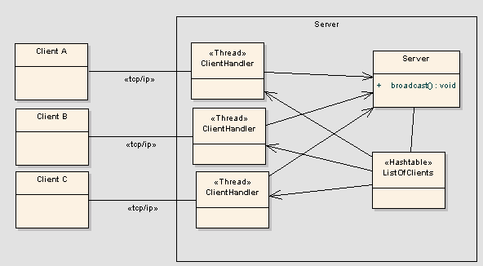

Fig. 2: Sample client-server architecture for socket programming

Sun Microsystems proposed a specification called Java Message Service (JMS) that provides a standard way of implementing MOM solutions. Code that runs on JMS-compliant MOM servers is portable across other JMS-compliant servers by other vendors. Vendors that implement the JMS specification can either provide a standalone JMS server e.g. SonicMQ or a built-in JMS server inside a J2EE Application Server e.g. IBM WebSphere Application Server (WAS). This is because the JMS specification is part of the J2EE specification. J2EE vendors must support JMS if they are at least J2EE 1.3-compliant. However, if they are not J2EE 1.3-compliant, they can choose whether or not to implement JMS.

Examples of typical J2EE servers are illustrated in Table 1.

Table 1: Vendors for J2EE, JMS and MOM servers

Vendor | J2EE Application Server | Stand-alone JMS Server | Proprietary MOM Server
IBM | WebSphere Application Server |  | WebSphereMQ
Microsoft |  |  | Microsoft Message Queue (MSMQ)
Sun | Sun ONE Application Server
Oracle | Oracle Application Server
BEA | WebLogic Application Server
JBoss Inc. | JBoss Application Server
Softwired Inc. |  | iBus
Progress |  | SonicMQ

With JMS, the system architecture would resemble Fig. 3.

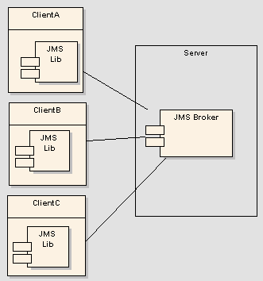

Fig. 3: Sample architecture that uses JMS

Because JMS is a type of Message-oriented-middleware (MOM), it also has the benefits of MOMs such as supporting “asynchronous calls between the client and server applications” [7]. With all these features, JMS is the silver bullet for developing distributed collaborative systems. However, JMS is relatively huge and complex because they are normally bundled together with the whole J2EE interfaces in the j2ee.jar file. Therefore this thesis will build a lightweight framework upon the JMS framework.

At the end of the day, this research builds a framework that provides the best of both worlds from socket programming and JMS techniques as shown in Table 2.

Table 2: Comparison among sockets, JMS and LICOSE

Feature | Socket Programming | JMS | LICOSE (LIghtweight COllaborative SErvices)
Simplicity | NO | YES | YES (Simpler than JMS)
Lightweight | YES | NO | YES

3.0 LICOSE PROGRAMMING MODEL

The challenge in this research is to design a framework that can be loaded from a constraint-limited environment such as Java Runtime Environment (JRE) for applets and Personal Digital Assistants (PDAs) to allow programmers to make high-level publish/subscribe calls that will be handled by the JMS Broker, i.e., the Message-Oriented Middleware (MOM).

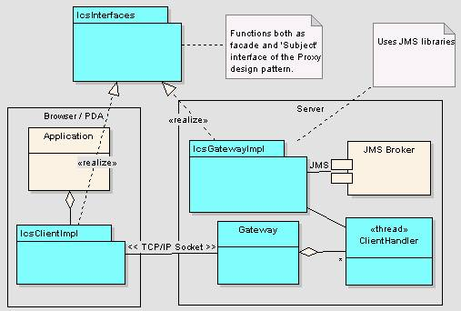

Fig. 4: Overall architecture of the LICOSE framework

Fig. 4 depicts the high-level design of a typical distributed collaborative system (DCA) that uses the LICOSE framework. The shaded portion of that diagram is the LICOSE implementation. Developers do not need to understand in detail, the inner workings of this portion. Therefore the TCP/IP socket connection between the Gateway and the lcsClientImpl is hidden from the developer.

We can see that the client and the server each have the package lcsClientImpl and lcsGatewayImpl respectively. These are the packages with classes that provide the implementation of LICOSE. Classes of both these packages must adhere to the standards set by the LICOSE interfaces that are contained in the lcsInterfaces package. It is also possible to allow a third party to develop the implementation for that set of interfaces. In this way, the developer can easily port his code across different vendors that can provide the same set of features but perhaps with better performance. In this case, the implementation packages (lcsClientImpl and lcsGatewayImpl) developed in this research can serve as a reference implementation for the LICOSE framework.

It is essential to understand the reason why those patterns drive the development of this framework. Many design patterns can be derived using commonality/variability analysis [5]. Similarly, this notion can also be extended to derive a framework. Based on the work of [6], the definition of commonality analysis is “the search for common elements that helps us understand how family members are the same”. For our case of distributed collaborative systems, the publish/subscribe mechanism is the basic element. This is because it facilitates asynchronous messaging so that messages can be propagated whenever an event occurs, without the need for subscribers to continually poll for new messages. In the example of a collaborative CASE tool, an event can occur when the user drags a class node to a new position. The message would contain the value of this new position before being propagated to the subscribers.

Variability analysis reveals how the members within a given commonality vary [5]. Using the same example of the above collaborative CASE tool, what is varying is the different ways to perform publish/subscribe messaging. In the server (where there is more processing power), we can implement the server-side LICOSE interface to make the underlying JMS calls to the JMS brokers. But for applications executing under the JRE or JVM for PDAs, the client-side will implement the same LICOSE interface differently by establishing sockets that communicate with a Gateway on the server-side. This is because the libraries to create Java sockets are available in the J2SE version 1.1.x (thus is suitable for low-end clients as shown in Table 3.

Table 3: Java version compatibility among front-end environments

Front-end environment | Supported libraries | Java Development Platforms
Mobile phones (MIDP-compliant) | MIDP, CLDC | J2ME
Jeode Embedded Virtual Machine (for PDA) | Personal Java (roughly equivalent to JVM 1.1.8 with some of JVM 1.2 classes). | J2SE
J2RE plug-in for applets | JVM 1.1.x (works without J2RE plug-in) | J2SE
J2RE plug-in for applets | JVM 1.2.x and above (works if the browser have the appropriate plug-in) | J2SE
JRE for Window-based applications. | Any JVM version | J2SE and J2EE

In this table, we see that only applications that are developed as a window-based client can use the J2EE library, which contain the JMS classes. This means that JREs for smaller front-end environments doesn’t really conform to API specifications of J2EE or J2SE.

4.0 Using the LICOSE API

This section will describe how the programmer will use the LICOSE framework for utilizing the publish/subscribe mechanism using an example of a collaborative CASE tool. The relevant LICOSE interfaces are as shown in Fig. 5.

This CASE tool is developed as an applet to execute on the browser under the JRE environment. This is a suitable example that proves the suitability of LICOSE to be used by the applet that downloads the library from the server. The applet is written to invoke the LICOSE interface for accomplishing its publish/subscribe operations.

The example used in this section only show what happens if a new UML element is added to the project workspace. If a user creates a UML element such as a class node, a message will be created and propagated to the server which will in turn publish this message to all the listeners. This can be done in a similar way for other events such as if a UML element is edited.

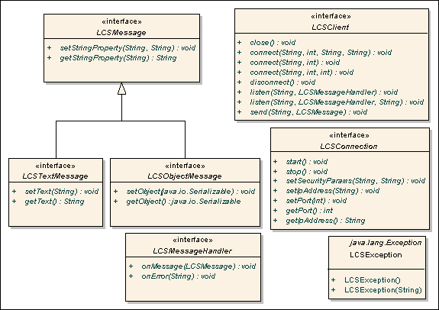

Fig. 5: LICOSE interfaces

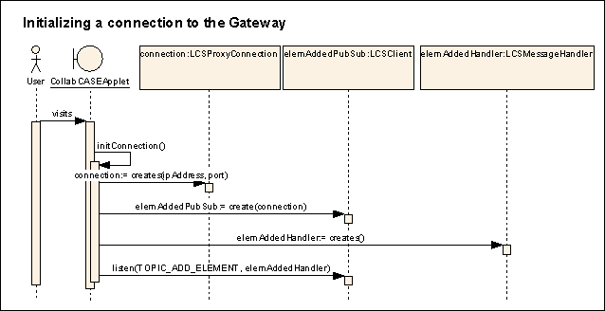

Fig. 6: Client-side implementation of LICOSE that initializes connection to the gateway.

When the applet is loaded, the applet framework will call the start() method of the applet. The developer can override this start() method to initialize the connection to the Gateway. As shown in Fig. 6, we can create our own initConnection() method to make this initialization. The elemAddedHandler is an instance of a class that implements the interface LCSMessageHandler. This class or its superclass will override the callback method that will be invoked by the LICOSE framework. By supplying this instance into the argument of the listen() method, this applet acts as a subscriber that will receive message when a new UML element is added onto a project from another remote applet. An example of a code snippet that implements the LCSMessageHandler is shown in Fig. 7.

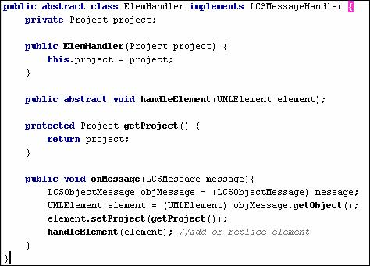

Fig.7: Code snippet of an example of using the LCSMessageHandler

The onMessage() method will be invoked by the LICOSE framework when a new message is propagated. This new message is of type LCSMessage. The message is type-casted into LCSObjectMessage because the UML element is transmitted as a serializable object. This object can be retrieved by using the LCSObjectMessage’s getObject() method. It can then be handled accordingly such as updating the project to reflect that the new element is added.

On the publisher side, whenever a user adds an element, the programmer will need to create an instance of LCSObjectMessage and set the object of the new UML element into this LCSObjectMessage. It will then need to invoke the send() method of the elemAddedPubSub class created earlier as shown in Fig.8.

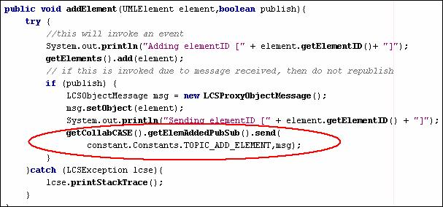

Fig. 8: Code that sends a message to a Topic.

The interaction that takes place from one end to the other can be depicted by the sequence diagram in Fig. 9.

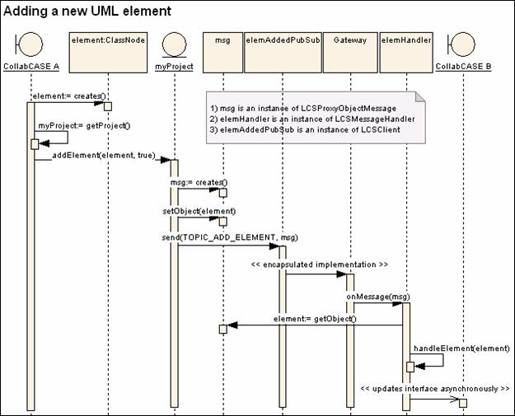

Fig. 9: Interaction between two remote clients

The invocation of the onMessage() method is handled by the framework. Hence, after the send() method is called from one side of the front-end, the developer can be assured that the onMessage() will be invoked on the other side of the front-end (i.e. another remote applet).

5.0 EVALUATION

The significance and justifications of this research are as follows:

- Real-time asynchronous messaging is possible. As JMS-vendors continue to compete to improve their proprietary implementations of JMS servers, our framework will leverage on these improvements without further efforts on our part. Hence, to achieve real-time message propagation is only a matter of choosing which JMS servers we want to use. An example of an infrastructure that utilizes JMS for real-time messaging is IMOTG where it is stated that “Java Message Service (JMS) API is used for real-time message notification” [8].

- Offers a lightweight framework suitable for loading onto constraint-limited front-end environment. This is possible because of its role as a proxy which merely acts as a “surrogate or placeholder for another object to control access to it” [9]. This underlying access is managed via sockets, and this implementation is hidden from developers.
- Simplicity of coding is achieved because the framework also doubles as a Façade for the JMS API. Hence developers do not need to learn all the APIs available in JMS and also need not learn multithreaded socket programming when developing distributed collaborative systems.

- A prototype CASE tool that was developed during this research can serve as a reference on how to use the LICOSE framework. As illustrated earlier in Fig.7 and Fig. 8, only a small amount of code is needed for the publish/subscribe messaging to work.

6.0 CONCLUSION

The contributions made by this research can open a new business opportunity for future service providers of this technology. The service provider can host a gateway that will intercept calls made from the front-end proxy and provide JMS-related feature by acting on behalf of the proxy to relay messages from the actual JMS server on the server-side.

With this in place, a framework is available for developers to develop any sort of collaborative systems other than CASE tools such as Instant Messenger, MMORPG games and so on.

REFERENCES

[1] Kevin Soon, A Lightweight Framework for Front-end Implementation of Distributed Collaborative Systems, Master’s Thesis, Malaysia University of Science and Technology, 2004.

[2] Haifeng Shen and Chengzheng Sun, “Flexible Notification for Collaborative Systems”, School of Computing and Information Technology, Griffith University, ACM, 2002.

[3] Jacob Harris¹ and Vivek Sarkar², “Lightweight Object-Oriented Shared Variables for Distributed Applications on the Internet”, Massachusetts Institute of Technology¹, IBM T. J. Watson Research Center², ACM, 1998.

[4] Eric Bruno, “Simplify JMS with the Facade Design Pattern”: http://www.devx.com/Java/Article/10586

[5] Alan Shalloway, James R.Trott, Design Patterns Explained: A New Perspective on Object-oriented Design, Addison-Wesley, 2002.

[6] Coplein J., Multi-Paradigm Design for C++, Addison-Wesley, 1998.

[7] Carnegie Mellon Software Engineering Institute: http://www.sei.cmu.edu/str/descriptions/momt.html

[8] “IMOnTheGo at a Glance”: http://java.sun.com/programs/solution-templates/pdf/Unbound_R2.pdf

[9] Gamma, E., Helm, R., Johnson, R. & Vlissides, J., Design Patterns: Elements of Reusable Object-oriented Software, Addison-Wesley, (2000).

BIOGRAPHY

Kevin Soon Swee Sin obtained his Master of Science in Information Technology from Malaysia University of Science and Technology and a Bachelor of Computer Science (Hons) degree from Universiti Sains Malaysia. His research interests include enterprise application development, object-oriented modeling, artificial intelligence and distributed applications. He has a number of professional certifications such as the Sun Certified Programmer for the Java 2 platform, IBM Certified Solutions Developer and IBM Certified Specialist.

Sellappan Palaniappan obtained his PhD in Computer and Information Science from the University of Pittsburgh in 1978. Currently, he is Associate Professor in the Department of Information Technology, Malaysia University of Science and Technology. His current research interests include service-oriented architectures, application frameworks, distributed databases, information integration, data mining and healthcare information systems.

This paper will use the term “workspace” to mean the shared view of the graphical design made by the CASE or EDA tool.
The term ‘programmer’ and ‘developer’ are used to refer to the user of the LICOSE framework. The aim of LICOSE is to allow them to develop distributed collaborative system at a higher abstraction.
The term ‘message’ is used to mean any data structure that is propagated to subscribers, when an event occurs.

